Special Educational Needs and Disabilities (SEND) Information Report


TONBRIDGE GRAMMAR SCHOOL

SEND Trustee:
Sarah Johnson
SEND Senior Management Lead:
Mr Chris Fitt
SENCO:
Mrs Tracy Stanley

SEND Team:
Mrs C Inglis (Asst SENCo)
Contact No 01732 365125
senco@tgs.kent.sch.uk

Approved by: | ATB | Date: September 2025
Last reviewed: | September 2024
Next review due by: | September 2026

Contents

1. What types of SEND does the school provide for? 4
2. Which staff will support my child, and what are their key responsibilities? 5
3. What should I do if I think my child has SEND? 7
4. What happens if the school identifies a need? 8
5. How will the school measure my child’s progress? 9
6. How will I be involved in decisions made about my child’s education? 10
7. How will my child be involved in decisions made about their education? 11
8. How will the school adapt its teaching for my child?......................................................................12
9. How will the school evaluate whether the support in place is helping my child? 13
10. How will the school ensure my child has appropriate resources? 13
11. How will the school make sure my child is included in activities alongside students who don’t have SEND? 14
12. How does the school make sure the admissions process is fair for students with SEN or a disability? 15
13. How does the school support students with disabilities? 15
14. How will the school support my child’s mental health and emotional and social development? 16
15. What support is in place for looked-after and previously looked-after children with SEND? 16
16. What support will be available for my child as they transition between classes or settings or in preparing for adulthood? 17
17. What support is available for me and my family? 17
18. What should I do if I have a complaint about my child’s SEND support? 19
19. Supporting documents 19
20. Glossary 20

The aim of this Information Report is to explain to parents and carers how we implement our SEND policy.
As educational professionals, we are all working towards the ultimate goal of growing independent young people as they prepare for adulthood. All provision and support we provide is working towards achieving the Kent Children and Young People (CYP) Outcomes Framework:

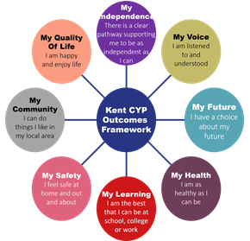

More information about our arrangements for SEND can be found in the SEND policy available on the School’s website.
Note: A glossary of specific terms is available at the end of this report.

Whole School Approach:
Tonbridge Grammar School values the abilities and achievements of all our students, including those who have special educational needs or a disability (SEN/SEND). We are committed to providing the best possible environment for the wellbeing and learning of everyone, enabling them to achieve the best possible outcomes for the next stages of their education and life.

1. What types of SEND does the school provide for?
The School provides for students with the following needs (as outlined in the SEND Code of Practice 2015):

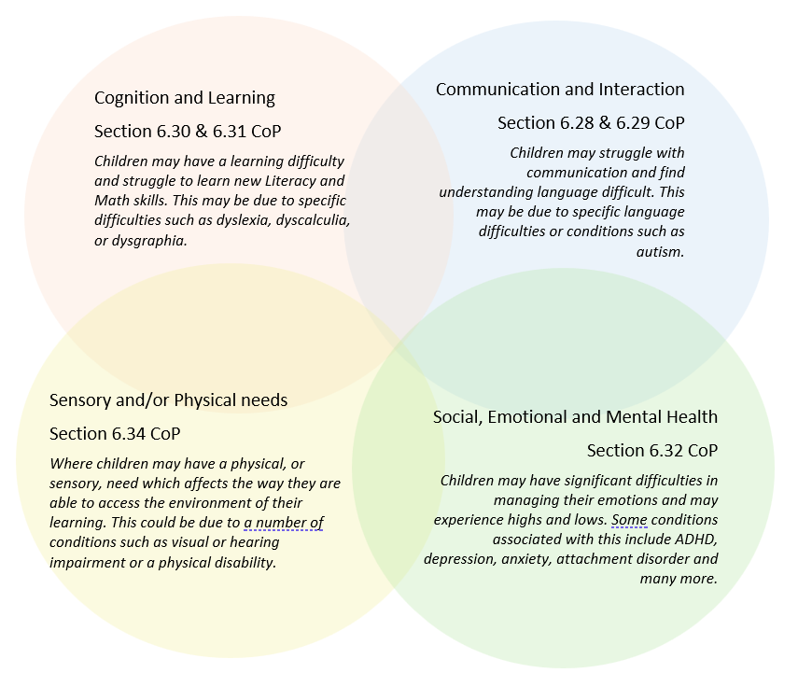
Often it may be found that children’s needs overlap and are rarely confined to one area of need, which is why it is important to gain a holistic overview of each child.
More information about the Areas of Need can be found in the Special educational needs and disability code of practice: 0 to 25 years SEND_Code_of_Practice_January_2015.pdf (publishing.service.gov.uk)

As of September 2025, we have 44 students receiving additional support for one or more of the categories of SEN identified above (an decrease of 21 the previous academic year). This includes 4 students with an Educational Health Care Plan (EHCP). 144 additional students are being monitored to see if they require additional support under any of the four areas mentioned above. There were 111 at this time last year.


2. Which staff will support my child, and what are their key responsibilities?

At Tonbridge Grammar School all staff are considered responsible for supporting the needs of students with SEND. Our staff are committed to regular, high-quality training to ensure that they have the knowledge and skills to better meet a wide range of student needs.
Below outlines key staff who will be supporting your child.
Our Special Educational Needs Co-ordinator, or SENCo
Our SENCo is Mrs Tracy Stanley
She has eight years’ experience in this role and has worked as a Mathematics teacher at the school since January 2015. She is a qualified teacher with a Master’s degree in Maths Education.
She achieved the National Award in Special Educational Needs Co-ordination in September 2019.
She is also a qualified Dyslexia Assessor and specialist Teacher, qualifying in 2022.
She has 34 hours per fortnight dedicated to SEN with 16 hours dedicated to teaching.
Assistant SENCo
We have an Assistant SENCo Mrs Claire Inglis who works 4 days a week and is non-teaching.
Class/subject teachers
All of our teachers receive in-house SEN training and are supported by the SENCO to meet the needs of students who have SEND. They have access to a variety of SEN written information.
Our staff have received training in the last 2 years on
Autism – through the Kent County Council and Autism Education Trust
Reminder of the 5 a-day strategies
Wellbeing Team
Additional support for mental health needs is provided by Student Support Co-ordinators, Mental Health Co-ordinators and our School Nurse
Academic Support Assistants
We have a team of two academic support assistants who are trained to deliver SEN provision for students with specific curriculum needs.

External agencies
Whenever necessary we will work with external support services to meet the needs of our students with SEND and to support their families. These may include:
- Child and adolescent mental health services (CAMHS)
- Education welfare officers
- Educational psychologists
- GPs or paediatricians
- NELFT practitioners
- Safeguarding services (KSCB)
- Kent School Nurses Service
- SEND Inclusion Advisor
- Specialist Teacher Service




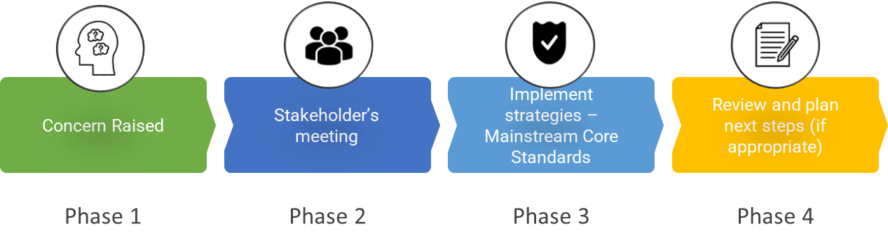
3. What should I do if I think my child has SEND?

Phase 1 | If you think your child might have SEND, raise your concern with the school so that the SENCO is aware.  We are happy to receive an email or phone call to discuss your concerns.  You can phone into the school on 01732 365125 and ask for the Assistant SENCo/ SENCo or email directly to senco@tgs.kent.sch.uk
Phase 2 | We can meet with you to discuss your concerns and try to get a better understanding of what your child’s strengths and difficulties are. Together we will decide what outcomes to seek for your child and agree on next steps. We will make a note of what’s been discussed and add this to your child’s record. We will create a Student Profile that will have strategies that will aid your child in class. We would not put your child on the SEN Register at this point as they would be supported in class or by the Wellbeing Team.
Phase 3 | We will implement the agreed strategies and monitor these over an agreed period of time. These are likely to be universal strategies set out in the mainstream core standards. A copy of this can be found here: https://www.kelsi.org.uk/__data/assets/pdf_file/0005/117257/Special-educational-needs-mainstream-core-standards-guide-for-parents.pdf . This will initiate the ‘Graduated Approach’ where support will be continually reviewed. See page 7 for more details.
Phase 4 | If we decide that your child needs additional SEND support, we will formally notify you and your child will be added to the school’s SEN register. They will receive additional support, and this will be reviewed using the assess, plan, do, review model.

4. What happens if the school identifies a need?
There are 4 phases followed when a potential additional need is identified:

All our class teachers are responsible for the monitoring of all students who have been identified as having SEND. They also review those who are not making the expected level of progress in their schoolwork or socially.
If the teacher notices that a student is having difficulties, they try to find out if the student has any gaps in their learning. If they can find a gap, the school will provide appropriate support. Students who don’t have SEND usually make progress quickly once the gap in their learning has been filled.
If the student is still finding it difficult to make the expected progress, the teacher will talk to the SENCO, and will contact you to discuss the possibility that your child has an additional need, and the school will follow the graduated approach (see next page).
A range of assessment opportunities to monitor and review student progress are used during the year including end of topic and term assessments, end of year internal examinations and teachers’ professional judgements and observations. Baseline data is collected at the beginning of year 7 through Cognitive Ability Tests (CATs), dyslexia screening (which gives an indication of the potential a student may have dyslexia but is not a formal assessment). Baseline data for Year 12 is collected using ALIS and previous GCSE results as well as the dyslexia screener. Further monitoring of annual end of year assessments, controlled in-class assessments and public examination results all contribute to the overall monitoring of academic progress and the effectiveness of provision. Additional data is collated through information requests from parents, records from primary schools or previous secondary schools, information supplied from outside agencies such as GPs or other agencies such as those relating to safeguarding and child protection.

5. How will the school measure my child’s progress?

We will follow the ‘graduated approach’ to meeting your child’s SEND needs.
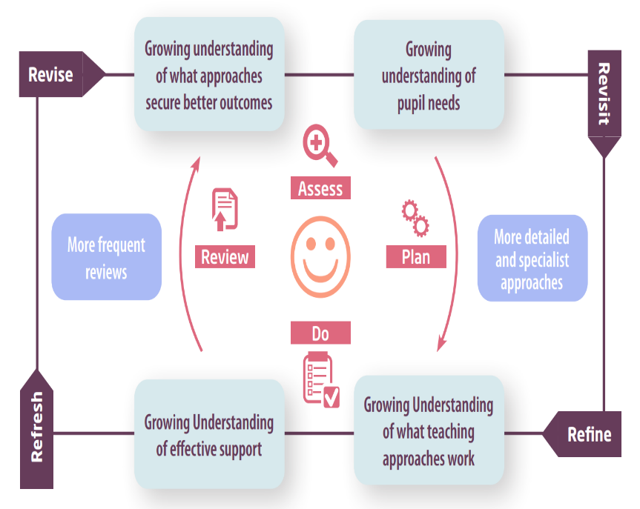
The graduated approach is a 4-part cycle of assess, plan, do, review.

Assess | If your child is not making the expected level of progress, we will make an assessment to find out what strengths and difficulties your child has. We will ask for you and your child’s input, as well as getting help from external professionals where necessary.
Plan | In discussion with you and your child, we will decide what outcomes we are hoping to achieve. We will decide on a plan of the support we will offer your child to help them meet those outcomes. We will make a record of this and share it with you and all relevant school staff – this will be in the form of a Student Profile.
Do | We will put our plan into practice.  The class teacher, with the support of the SENCO, will be responsible for working with your child on a regular basis, and making sure the support we put in place is having the impact we intended.
Review | We will assess how well the support we put in place helped the student to meet the outcomes we set. We will use our improved understanding of your child’s needs to improve the support we offer; this may mean the Plan, Assess, Do, Review cycle continues.

6. How will I be involved in decisions made about my child’s education?

We will provide three reports on your child's progress in their subjects. There is also one Parent Consultation Evening in each year.
If you have a child with additional needs and is on the SEN register you can request a meeting or phone call when required. If your child has an EHC Plan there will be two set meetings a year including the Annual Review of the EHC Plan.
A member of staff who knows your child well will meet you, to:
- Set clear outcomes for your child’s progress.
- Review progress towards those outcomes
- Discuss the support we will put in place to help your child make that progress
- Identify what we will do, what we will ask you to do, and what we will ask your child to do

We know that you’re the expert when it comes to your child’s needs and aspirations. So, we want to make sure you have a full understanding of how we’re trying to meet your child’s needs, so that you can provide insight into what you think would work best for your child.
We also want to hear from you as much as possible so that we can build a better picture of how the SEND support we are providing is impacting your child outside of school.
If your child’s needs or aspirations change at any time, please let us know right away so we can keep our provision as relevant as possible.
If you have concerns that arise between these meetings, please contact the SEN Team.

7. How will my child be involved in decisions made about their education?

The level of involvement will depend on your child’s age and individual needs. We recognise that no two pupils are the same, so we will decide on a case-by-case basis, with your input.
It is important to us that the child’s voice is heard in our SEN process.
We may seek your child’s views by asking them to:
- Attend meetings to discuss their progress and outcomes
- Discuss their views with a member of staff who can act as a representative during the meeting.
- Complete a survey



8. How will the school adapt its teaching for my child?
Your child’s teachers are responsible and accountable for the progress and development of all the students in their class.
High-quality teaching is our first step in responding to your child’s needs. We will make sure that your child has access to a broad and balanced curriculum in every year they are at our school.
We will adapt our approaches to how we teach to suit the way the student works best. There is no 'one size fits all’ approach to adapting the curriculum, we work on a case-by case basis to make sure the adaptations we make are meaningful to your child and are guided by the Mainstream Core Standards in the first instance.

These adaptations may include:
- Adapting our approaches, for example, giving longer processing times, pre-teaching of key vocabulary, reading instructions aloud, handouts, scaffolding lesson materials, lesson resources uploaded to access after the lesson. This list is not exhaustive.


- Using recommended aids, such as laptops, coloured overlays, larger font, coloured paper etc.

- We have set protocols for students with Autism or Attention Deficit Disorder (based on mainstream core standards)


We may also provide the following interventions:
Access to our Specialist Literacy Teacher – who can provide 1-1 or groupwork on literacy skills and study skills.
Time-out in our Student Support Hub
Access to the School Nurse
Access to school counselling or our Mental Health Needs Co-ordinators
Mentors to support Learning.
Access Arrangements such as extra time in public examinations as regulated by the JCQ board
and the International Baccalaureate Organisation. Additional assessment will be required for
access arrangements.
These interventions are part of our contribution to Kent County Council’s local offer.

9. How will the school evaluate whether the support in place is helping my child?

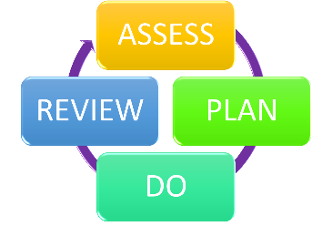
We will evaluate the effectiveness of provision for your child by:
- Reviewing their progress towards their learning goals each term
- Reviewing the impact of interventions after 6 – 8 weeks
- Using student questionnaires
- Monitoring by the SENCO
- Holding an annual review (if they have an education, health and care (EHC) plan)

10. How will the school ensure my child has appropriate resources?
It may be that your child’s needs mean we need to provide additional resources such as:
- Additional resources to support their learning
- Adaptations to in class support
- Further training for our staff
- External specialist expertise
Where appropriate, we will consult with external agencies to get recommendations on what will best help your child access their learning and use our best endeavours to ensure these are supplied.
The School is committed to specialist SEN provision through our general annual grant (GAG funding). This enables the School to employ a Specialist Teacher and School Counsellor. Budgets are also allocated for specialist training and updating of assessment tools, software and essential equipment including technology, assessment booklets and physical aids. The School is grateful for additional funding from the Debney Fund that enables further counselling provision.

11. How will the school make sure my child is included in activities alongside students who don’t have SEND?


The expectation is that all schools provide an inclusive provision for all students. It may be necessary for some students to receive interventions in addition to a broad and balanced curriculum.
All of our extra-curricular activities and school visits are available to all our students.
All students are encouraged to go on our school trips, including Year 7 and 9 activity camp.
All students are encouraged to take part in extra-curricular activities including Sports Day, Interhouse activities and inter-disciplinary week.
We will endeavour to make reasonable adjustments to make sure that students with SEN or disability can be included in all activities.

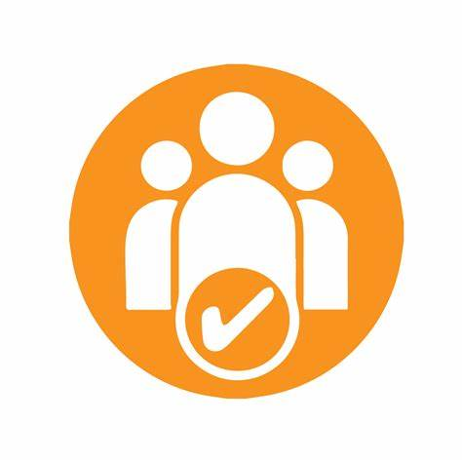
12. How does the school make sure the admissions process is fair for students with SEN or a disability?

Admission to our school is detailed in our Admissions Policy available here: Admission Policy
If a prospective student has SEN or a disability we would be in contact with parents and previous school to ensure a smooth transition.
The SEN Team are available on information evenings for prospective students to discuss what we can offer on a more individual basis.
As we do not ask about SEN in our application process, we would like to assure you that this information would not be used to unfairly disadvantage a student on our waiting list for places as we are often oversubscribed.
We follow the Local Authority criteria of accepting students with an EHCP when we are the named school, and they have priority on our admission criteria.

13. How does the school support students with disabilities?


You’re disabled under the Equality Act 2010 if you have a physical or mental impairment that has a ‘substantial’ and ‘long-term’ negative effect on your ability to do normal daily activities.
The school makes reasonable adjustments in order to accommodate disabled students – including lifts in buildings and accessible facilities. See our Accessibility Plan for more details available here: Accessibility Plan 2023-26.
There are currently a range of new and old buildings, so some adjustments are made such as using downstairs classrooms if needed.

14. How will the school support my child’s mental health and emotional and social development?
We provide support for students to progress in their emotional and social development in the following ways:
- We have a wellbeing hub/ quiet area where students can sit and be quiet and recoup. There is also a quiet study area for individual work.
- The Form Tutor will be able to check in on students daily
- We have a large wellbeing team who are on hand all day as do not have a teaching commitment. This includes student support co-ordinators designated to a specific year group, mental health co-ordinators, school counsellor, school nurse and assistant SENCo.
- Mentoring provision from wellbeing team for students with support plans incorporates SEN pupil profiles
- We have a ‘zero tolerance’ approach to bullying. Our bullying policy is available here: Anti-bullying policy

15. What support is in place for looked-after and previously looked-after children with SEND?


Miss Bishop (Designated Safeguarding Lead) and Miss Darby (Safeguarding Officer) will work with Mrs Tracy Stanley (SENCO) to make sure that all teachers understand how a looked-after or previously looked-after student’s circumstances and their SEND might interact, and what the implications are for teaching and learning.
Students who are looked-after or previously looked-after will be supported much in the same way as any other child who has SEND. However, looked-after students will also have a personal education plan (PEP). We will make sure that the PEP and any SEND support plans or EHC plans are consistent and complement one another.

16. What support will be available for my child as they transition between classes or settings or in preparing for adulthood?
Between years

To help students with SEND be prepared for a new school year we:
Talk to the teachers – both current and new to ensure that the student’s Pupil Profile is up to date with relevant information.
Talk to the student about any worries they have before they move on a year.

Between schools
When your child is moving on from our school, we will ask you and your child what SEN information you want us to share with the new setting.
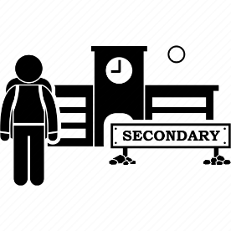
Students will be prepared for the transition by:
The SENCO of the primary school meeting with our SENCO to discuss the needs of the incoming students near the end of the summer term.
We arrange meetings with the parents of incoming students to discuss how we can best welcome their child into our community.
Onto adulthood (for secondary schools)

We provide all our students with appropriate advice on paths into work or further education.
We work with the student to help them achieve their ambitions, which can include goals in higher education, employment, independent living and participation in society.

17. What support is available for me and my family?
If you have questions about SEND, or are struggling to cope, please get in touch to let us know. We want to support you, your child and your family.
To see what support is available to you locally, have a look at the Kent County Council (KCC) local offer, called the SEND Information Hub
https://www.kent.gov.uk/education-and-children/special-educational-needs
We have a large catchment area do you may live in another local authority so here are further links to their local offers:
Medway Local Offer - https://www.medway.gov.uk/localoffer
Bromley - https://www.bromley.gov.uk/LocalOffer
Bexley - https://bexleylocaloffer.uk/
East Sussex - https://localoffer.eastsussex.gov.uk/
If you do not live in these areas, then use your regular search engine with your local authority’s name and the words ‘Local Offer’.
Our local special educational needs and disabilities information advice and support services (SENDIAS) organisations are:
IASK - https://www.iask.org.uk
This is the link to all local SENDIASS organisations in our catchment area.
Local charities that offer information and support to families of students with SEND are:
National charities that offer information and support to families of students with SEND are:
- IPSEA
- SEND family support
- NSPCC
- Family Action
- Special Needs Jungle

18. What should I do if I have a complaint about my child’s SEND support?
Complaints about SEND provision in our school should be made to the SENCo in the first instance. They will then be referred to the school’s complaints policy available here: Complaints Policy
If you are not satisfied with the school’s response, you can escalate the complaint. In some circumstances, this right also applies to the student themselves.
To see a full explanation of suitable avenues for complaint, see pages 246 and 247 of the SEND Code of Practice.
If you feel that our school discriminated against your child because of their SEND, you have the right to make a discrimination claim to the first-tier SEND tribunal. To find out how to make such a claim, you should visit: https://www.gov.uk/complain-about-school/disability-discrimination
You can make a claim about alleged discrimination regarding:
- Admission
- Exclusion
- Provision of education and associated services
- Making reasonable adjustments, including the provision of auxiliary aids and services
Before going to a SEND tribunal, you can go through processes called disagreement resolution or mediation, where you try to resolve your disagreement before it reaches the tribunal. The link is https://www.globalmediation.co.uk/service/special-educational-needs-disability/

19. Supporting documents
- Accessibility Plan
- Attendance policy
- Behaviour Policy
- Child Protection and Safeguarding Policy
- Complaints Policy

- Diversity and Inclusion Policy
- SEND policy
- Supporting Students with Medical Needs

These can all be found on the school website.

20. Glossary
- Access arrangements – special arrangements to allow students with SEND to access assessments or exams
- Annual review – an annual meeting to review the provision in a student’s EHC plan
- Area of need – the 4 areas of need describe different types of needs a student with SEND can have. The 4 areas are communication and interaction; cognition and learning; physical and/or sensory; and social, emotional and mental health needs.
- CAMHS – child and adolescent mental health services – also known as CYPMHS
- Differentiation – when teachers adapt how they teach in response to a student’s needs
- EHC needs assessment – the needs assessment is the first step on the way to securing an EHC plan. The local authority will do an assessment to decide whether a child needs an EHC plan.
- EHC plan – an education, health and care plan is a legally-binding document that sets out a child’s needs and the provision that will be put in place to meet their needs.
- First-tier tribunal/SEND tribunal – a court where you can appeal against the local authority’s decisions about EHC needs assessments or plans and against discrimination by a school or local authority due to SEND
- Graduated approach – an approach to providing SEND support in which the school provides support in successive cycles of assessing the student’s needs, planning the provision, implementing the plan, and reviewing the impact of the action on the student
- Intervention – a short-term, targeted approach to teaching a student with a specific outcome in mind
- Local offer – information provided by the local authority which explains what services and support are on offer for students with SEND in the local area
- Outcome – target for improvement for students with SEND. These targets don't necessarily have to be related to academic attainment
- Student Profile – a document that the school uses to list the strengths and additional needs of a student and the list of the strategies teachers and staff can put in place to support that student. It is regularly updated with information from staff, parents and students.
- Reasonable adjustments – changes that the school must make to remove or reduce any disadvantages caused by a child’s disability
- SENCO – the special educational needs co-ordinator
- SEN – special educational needs
- SEND – special educational needs and disabilities
- SEND Code of Practice – the statutory guidance that schools must follow to support students with SEND
- SEND information report – a report that schools must publish on their website, that explains how the school supports students with SEND
- SEND support – special educational provision which meets the needs of students with SEND
- Transition – when a student moves between years, phases, schools or institutions or life stages

